CHAROTAR UNIVERSITY OF SCIENCE AND TECHNOLOGY (CHARUSAT)
SUBJECT: WEB DEVELOPMENT FRAMEWORKS (ITUE203)

SEMESTER: 3RD, 2026-27 (ODD)

Practical 8: MySQL Schema Design, ER Model, PDO Connectivity, and Prepared Statements

Problem Definition: Design the database for the StudentHub portal with students, events and registrations. Create suitable MySQL tables with primary keys and foreign keys, prepare an ER model, and connect the PHP application with MySQL. PDO connectivity and prepared statements are used to make database operations safer and easier to manage.

A. Theory
1. Is the schema normalized properly?
Yes. The StudentHub database can be normalized by keeping students, events and registrations in separate tables. The students table stores student details, the events table stores event details, and the registrations table connects students with events using their IDs. This reduces duplicate data and makes the database easier to update. It also supports the many-to-many relationship between students and events.
Reference websites: MySQL Documentation, PHP Manual – PDO, PHP Manual – Prepared Statements
2. Are primary keys and foreign keys correctly defined?
A primary key uniquely identifies each record in a table. For example, student_id, event_id and registration_id can be primary keys. Foreign keys connect related tables. In the registrations table, student_id can refer to the students table and event_id can refer to the events table. This helps maintain correct relationships and prevents invalid references.
Reference websites: MySQL Documentation, PHP Manual – PDO, PHP Manual – Prepared Statements
3. Is the database connection handled securely?
The PHP application can connect to MySQL using PDO. The connection details can be kept in a separate db.php file. Prepared statements should be used instead of directly adding user input to SQL queries. They use placeholders and help protect the application from SQL injection. PDO error handling also makes database problems easier to manage.
Reference websites: MySQL Documentation, PHP Manual – PDO, PHP Manual – Prepared Statements

B.output

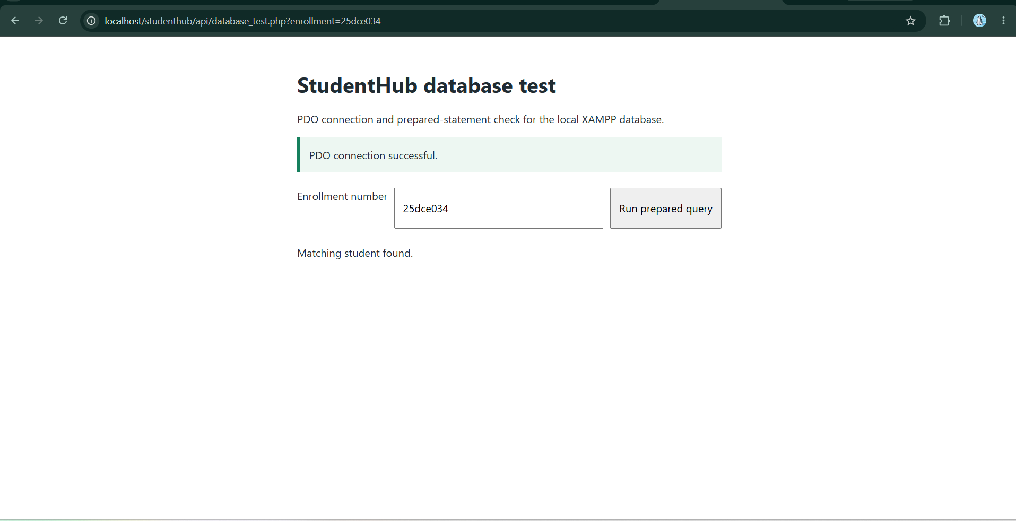

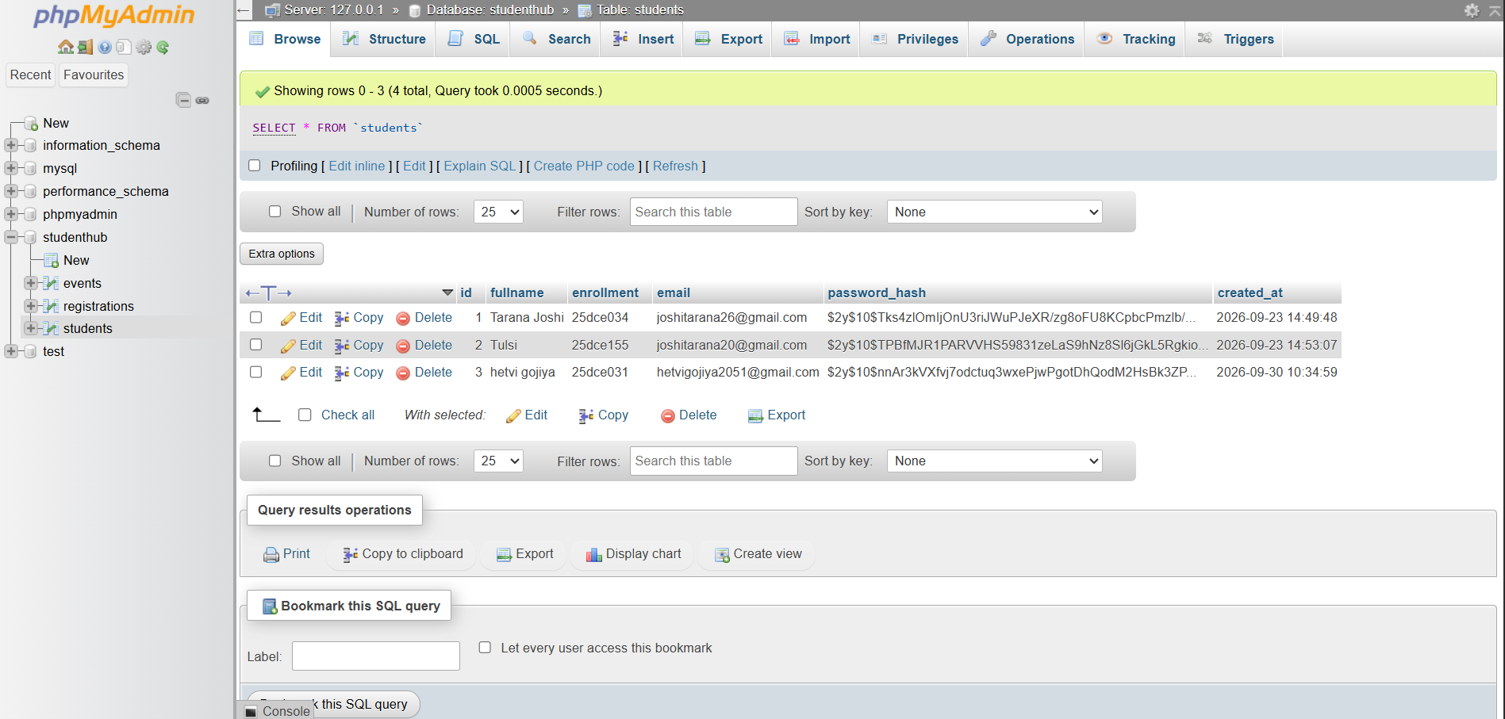

.

C. GitHub Repository Link
[Paste GitHub repository link here]
D. Challenges Faced
- Understanding how primary keys and foreign keys are used to connect tables.
- Creating the correct relationship between students, events and registrations.
- Setting up the PDO connection and checking database connection errors.
- Understanding placeholders and parameter binding in prepared statements.
E. Learning Outcomes
- Understand the basic process of designing a relational MySQL database.
- Create an ER model and identify relationships between database entities.
- Use primary keys and foreign keys to maintain relationships between tables.
- Connect a PHP application with MySQL using PDO.
- Understand the use of prepared statements for safer SQL queries.

Result: The StudentHub database was created successfully with students, events and registrations tables. The relationships were defined using primary and foreign keys. The PHP application was connected to MySQL using PDO, and a prepared statement was used for a sample query.

